Train-the-Trainer Workshop:
A Practical Approach to Training Adults
Participant’s Guide

Table of Contents

Adult Learning Assumptions and Motivation 6
Andragogy 7
The Brain and the Adult Learner 8
The Physiology of Learning 9
Getting Out of “Comfort Zones”: Equilibrium and Disequilibrium in Learning 9
Adult Learning Theories 10
Theory Definitions & Characteristics 11
Adult Learning Styles & Preferences 12
Learning Styles 13
VAK 13
4MAT Overview 14
4MAT Types 14
Considerations for Respect and Inclusion 15
Instructional Design Models Overview 16
Instructional Design Principles 17
Benefits of Instructional Design 17
ADDIE Instructional Design Model 18
SAM Instructional Design Model 19
ARCS Instructional Design Model 20
Needs Analysis 21
Analysis to Establish Need for Training 22
Learning Outcomes 23
SMART Outcomes 24-25
Content Design & Development 26
Activity-Based Learning: 27
Training Delivery 28
Multimedia in Learning 29
Outcomes Assessment (Learner) 30
Assessment and Evaluation 31
Three Types of Assessment 31
Assessment Methods and Implementations 32
Validity and Reliability of Assessment 33
Tips for Increasing Validity and Reliability 33
Evaluating Learning Event Effectiveness 34
Program Evaluation 35
Trainer Ethics 36
Ethics Case Scenarios 37
Organization Training Plans Project 38
Resources, Recap, & Action 39
My Workshop Action Plan 40
Resources 41
IACET’s Mission and Background 42

Module

1

Adult Learning Assumptions and Motivation

Learning Outcomes:
- Define “andragogy.”

- Identify five assumptions that affect adult learner motivation.

Andragogy

“Andragogy” is defined as:

Definition drilldown
1.

2.

3.

4.

The five assumptions that affect adult learners’ motivation:
1.

2.

3.

4.

5.

Module

2

The Brain and the Adult Learner

Learning Outcomes:
- Describe how the physiology of the brain relates to learning in adulthood.

- Describe “disequilibrium’s” role in adult learning.

The Physiology of Learning

The adult brain has ______________ neurons. Most learning and development occurs in the brain through the process of strengthening and weakening _______________connections.
Adults learn best when they ________________ or ________________networks that have been created through previous learning and experience.
The networks are an adult learner’s _____________________.

Getting Out of “Comfort Zones”: Equilibrium and Disequilibrium in Learning

___________________________ is the sense of ease one feels in the information most familiar to them.

___________________________ occurs is an unpleasant state when learners become aware of the shortcomings or issues in their existing thinking and are dissatisfied.
.
The best learning takes place in state of _______________________________-.

Module

3

Adult Learning Theories

Learning Outcomes:
- Identify most common adult learning theories.

- Discuss practical instructional ideas and strategies that represent each theory.

Theory Definitions & Characteristics

Behaviorist

- Seeks to ___________ behavior.
- Says all things we do are ___________.
- Behavior is manipulated by conditioning.
  - Classical - involuntary
  - Operant – reinforcers
- Pure behaviorists are not concerned with internal process but with _______________.

Cognitivist

- Focuses on how students _________.
- Says an instructor can’t force a learner to learn.
- _________ and __________ memory are considered.
- Would include _____________________________.

Constructivist

- Recognizes the instructor

_______________________________________.

- Learners are encouraged to learn main ideas

_________________________________.

Module

4
Adult Learning Styles and Preferences

Learning Outcomes:
- Compare multiple learning styles.

- Identify cultural dimensions and considerations for adult learning/training.

Learning Styles

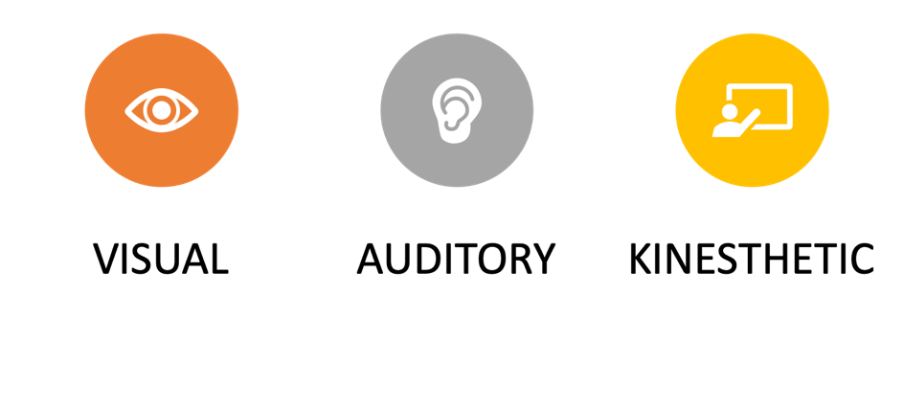
VAK

Visual:

Auditory:

Kinesthetic:

4MAT
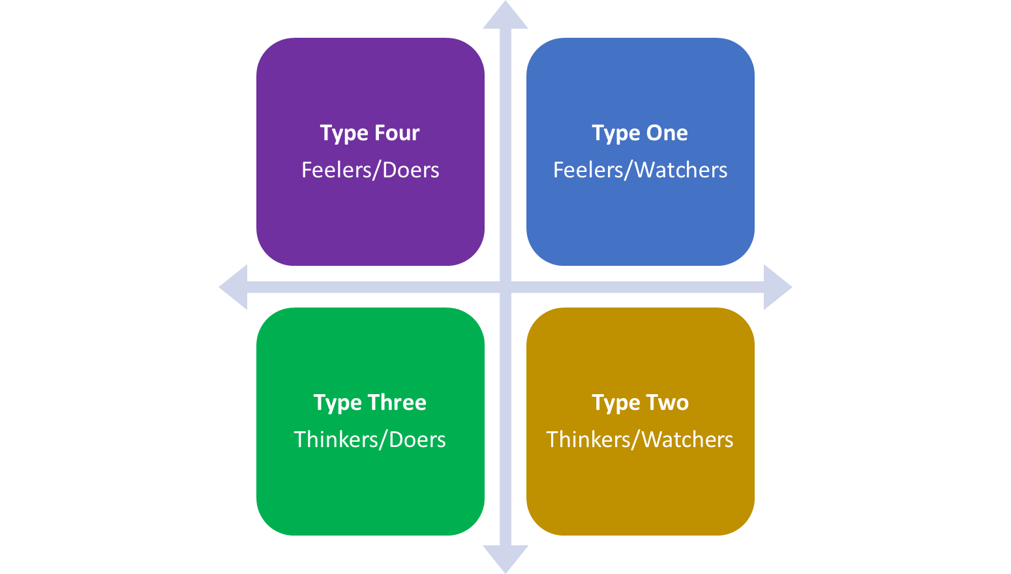

Type 1
“Seeks meaning and clarity”

Type 2
“Finds Order”

Type 3
“Experiments

Type 4
“Creates”

Considerations for Respect and Inclusion

What are some cultural considerations to keep in mind throughout the instructional design process?

How can we create a safe, inclusive, and respectful learning environment?

Keep it Practical: What can you do for your learners in your organization to help them feel included and respected?

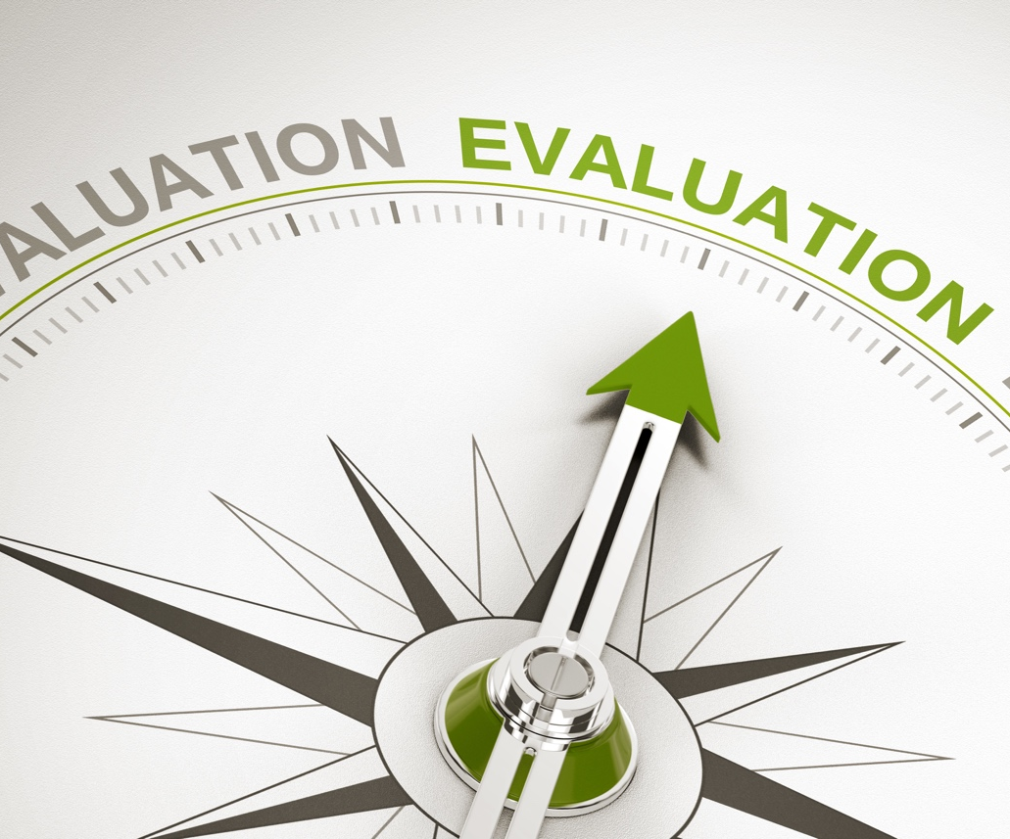
Module

5
Instructional Design Models Overview

Learning Outcomes:

Describe the importance of sound instructional design for adult learning.

Compare common instructional design models and approaches.

Instructional Design Principles

- How do you develop learning events?

- Is there a particular process you use?

- Keep it Practical: How does our discussion regarding adult learning, the brain, styles, and theories inform our approach to designing learning?

Benefits of Instructional Design

- A reproduceable methodology for learning event design

- Systematic process for the development and design of learning events

- A way to ensure consistency among various learning events

ADDIE Instructional Design Model

ADDIE Advantages

ADDIE Disadvantages

SAM Instructional Design Model
SAM is an instructional design model developed by Michael Allen, a recognized leader in the area of instructional design. Allen’s 2012 book, Leaving ADDIE for SAM - An Agile Model for Developing the Best Learning Experiences outlines why an alternative model to ADDIE was needed in instructional design and makes the case for a more flexible model provided in SAM.

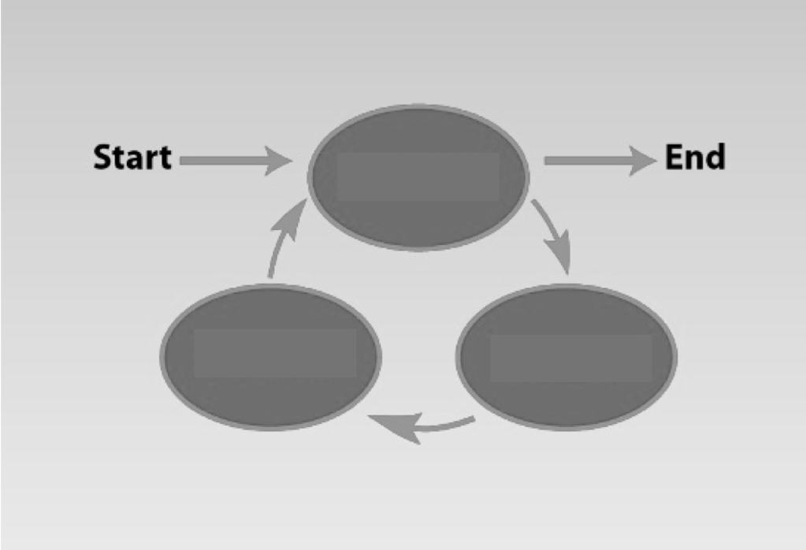

SAM Advantages

SAM Disadvantages

ARCS Instructional Design Considerations
The Attention, Relevance, Confidence, Satisfaction (ARCS) instructional design organizational tool can be combined with instructional design models such as Analysis, Design, Development, Implementation, Evaluation (ADDIE) or the Successive Approximation Model (SAM). The primary objective of ARCS is providing motivation to learn.
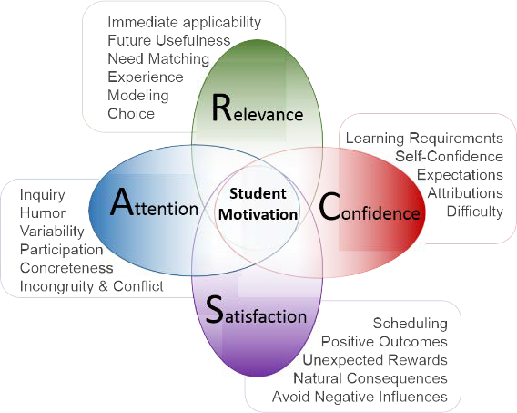
Image courtesy of www.itap.purdue.edu

Keep it Practical: How does this model apply to your experiences with motivating adult learners?

Module

6

Needs Analysis

Learning Outcomes:
- Identify various approaches to conducting needs analysis.
- Design needs analysis questions.
- Formulate strategies for conducting needs analysis.

Analysis to Establish Need for Training

The first step in instructional design is to ensure there is a ______________________.

Sources and Methods of Data Collection for Needs Analysis are:

Typical Needs Analysis Questions are:

Module

7

LEARNING OUTCOMES

Learning Outcomes:
- Describe the link between needs analysis and creating SMART learning outcomes (using Bloom’s Taxonomy).

- Apply Bloom’s Taxonomy to determine the appropriate outcome verbs based on level of learners.

- Develop SMART learning outcomes.

Learning Outcomes

Learning outcomes should link to _______________________________.
Learning Outcomes Considerations are:
1.

2.

3.

4.

SMART Outcomes

1The term objective and outcome are synonymous.

Language to Avoid in Creating Learning Outcomes:

Learning Outcome Examples:

My Learning Outcomes:

Module

8

Content Design and Development

Learning Outcomes:
- Define the major delivery modalities (online, blended, instructor-led onsite).

- Define and identify critical factors in design for synchronous and asynchronous learning.

- Define “activity-based learning”.

- Develop learning activities aligned with learning outcomes.

Activity-Based Learning:

Definition:

Activity-Based Learning:

Activity | How to Apply to Adult Learning
Service Learning
Reflections: Self reflections; Group reflections
Student moderation (online)
Case Studies
Oral Presentations
Designing Research and Projects
Submitting for Publication
Online Jigsaw Collaboration
Discussions and Debates
Portfolio Evaluation
Role Playing
Internet ”Scavenger Hunts”

Module

9

Training Delivery

Learning Outcomes:
- Distinguish between various types of multimedia for adult learning.
- Identify best practices for using media in the classroom.
- Apply strategies to address challenging instructor-led and online learner/learning situations.

Multimedia in Learning
General Best Practices are:

Module

10

Outcomes Assessment (Learner)

Learning Outcomes:
- Differentiate between “learner assessment” and “learning event/experience evaluation.”

- Distinguish between placement, formative, and summative assessments.

- Synthesize needs, learning outcomes, content, methods, and Bloom’s Taxonomy to learner assessment.

- Differentiate between validity and reliability.

- Discuss methods and tools for collecting assessment data.

- Formulate assessment items aligned with measuring mastery of learning outcomes.

Assessment and Evaluation

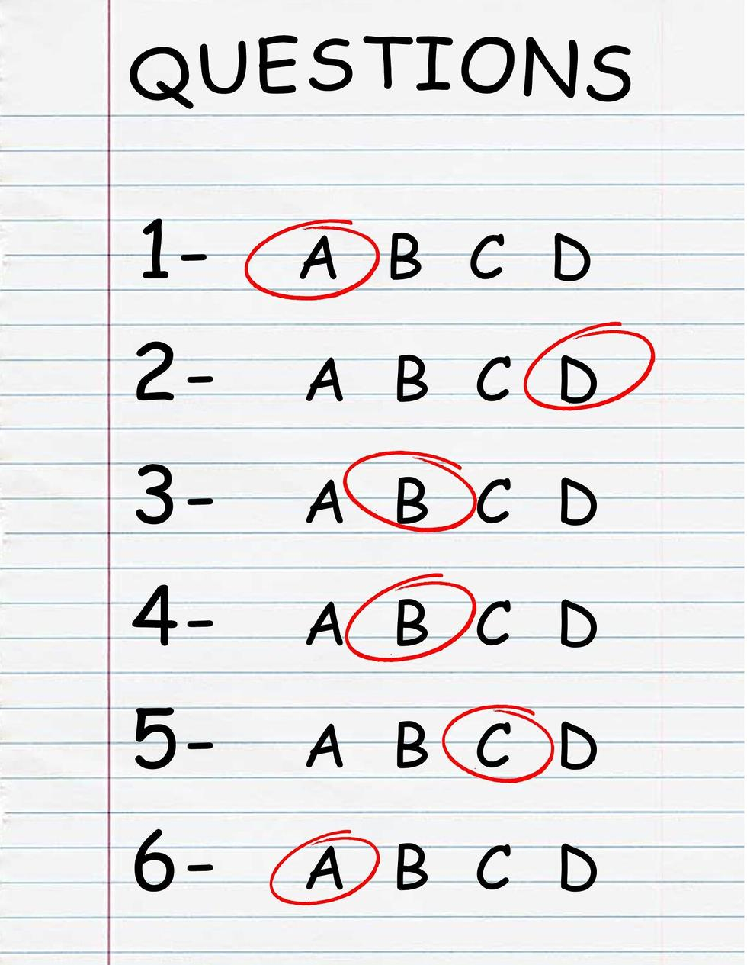
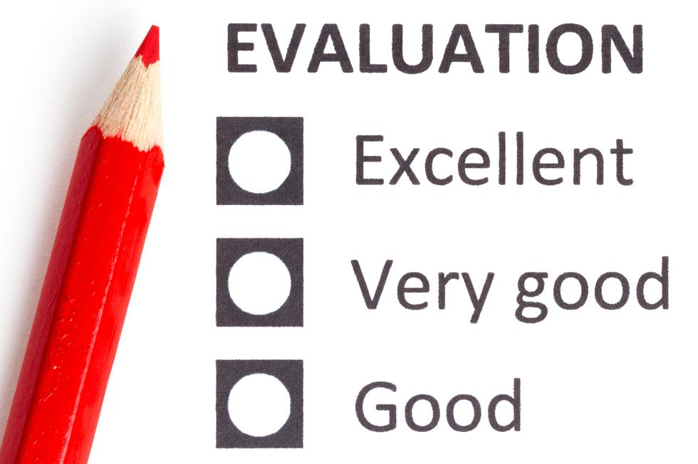
What are the differences?
ASSESSMENT

Assessment Evaluation

Three Types of Assessment

- ______________________assessment is used to determine what the learners know about the content prior to the learning event. This will help identify what the learners know and the instruction’s focus.
- _______________________assessment is used during the instruction to determine how learners are progressing through the instruction and provides information on whether additional instruction (remediation) is needed.
- ______________________assessment is used at the end of the learning event to determine each learner’s mastery level and to assign grades.

Assessment Methods and Implementations

Assessment Type | Advantages | Disadvantages
Multiple Choice
True/False
Fill-in-the-blank
Matching
Short Answer/Essay
Games

Validity and Reliability of Assessment

While this is not a comprehensive guide on development of assessments, instructional designers and instructors should at least be familiar with the different types of validity in assessment development:

_______________ is the degree to which an assessment tool measures what it is supposed to measure.

_______________ is the degree to which an assessment tool produces consistent results over time.

Tips for Increasing Validity and Reliability

1.

2.

3.

4.

5.

6.

Module

11

Evaluating Learning Event/ Experience

Effectiveness

Learning Outcomes:
- Discuss the four levels of Kirkpatrick’s Program Evaluation Model.
- Discuss methods and tools for collecting evaluation data.
- Formulate items to include on post-learning event evaluations and identify what Kirkpatrick levels they represent.

Program Evaluation
(Adapted from Donald Kirkpatrick's Learning Evaluation Model)

Level | Evaluation  type | Evaluation Description & Characteristics | Evaluation Tools & Methods | Relevance & Practicability
1 | Reaction | Reaction evaluation is how the delegates felt about the training or learning experience. | ”Happy sheets”, or feedback forms, verbal reaction, post-training surveys and questionnaires. | Quick and easy to obtain. Not expensive to gather or analyze.
2 | Learning | Learning evaluation is the measurement of the increase in knowledge —before and after. | Typically, assessments or tests before and after the training.  Interviews or observations can also be used. | Relatively simple to set up. Clear-cut for quantifiable skills; more difficult for complex learning.
3 | Behavior | Behavior evaluation is the extent of applied learning back on the job (i.e., implementation). | Observations and interviews over time to relevance and sustainability of change. | Measurement of behavior change typically requires cooperation and skill of line managers.
4 | Results | Results evaluation is the effect on the business or environment by the trainee. | Measures are already in place via normal management systems and reporting. The challenge is to relate to the trainee. | Individually not difficult; unlike whole organization. Process shall attribute clear accountabilities.

For more detailed information on training evaluation IACET recommends the book, Kirkpatrick’s Four Level of Training Evaluation available at www.kirkpatrickpartners.com.

Module

12

Trainer Ethics

Learning Outcomes:
- Identify the major considerations around using copyrighted material.
- Analyze challenges around instructors’ potential proprietary interest.
- Apply methods to address confidentiality during the learning event and/or experience.

Scenario | What would you do? | Why?
Case Scenario 1

Case Scenario 2
Case Scenario 3

Ethics Case Scenarios
Module

13

Organization Training Plans Project

Learning Outcomes:

Synthesize the concepts from previous modules.

Create an Organization Training Plan and presentation.

Module

14

Resources, Recap, and Action!

Learning Outcomes:
- Discuss additional resources available.
- Develop a plan for implementing the knowledge/tools learned in class.

My Workshop Action Plan

I will commit to implementing these two concepts and/or skills:

I will implement these concepts and/or skills by doing the following:

I will get some help from:

Resources

Allen, M. (2012). Leaving ADDIE for SAM - An agile model for developing the best learning experiences. Washington DC: American Society for Training and Development.
Association for Talent Development. (2016). Evaluating learning - getting to measurements that matter. Washington DC: Association for Talent Development.
Kaufman, R. & Guerra-Lopez, I. (2012). Needs assessment for organizational success.
Knowles, M., Holton, E., & Swanson, R. (2005). The adult learner, the definitive classic in adult education and human resource development. Burlington, MA: Elsevier.
Mehegan-Smith, R. (2011). Strategic learning alignment (Making training a powerful business partner).
Merriam, S. Caffarella, R., & Baumgartner, L., (2006). Learning in adulthood.
Phillips, P., & Phillips, J. (2005). Return on investment (ROI) basics. Washington DC: Association for Talent Development.
Wood, S., Wood, E., & Boyd, D. (2005). The world of psychology (Fifth edition ed.). Boston: Pearson.

IACET’s Mission and Background
The International Association For Continuing Education And Training's (IACET) mission is to advance the global workforce by providing the standard framework for quality learning and development through accreditation.
IACET’s history includes the development of the original Continuing Education Unit (CEU) and the creation and maintenance of the ANSI/IACET Standard for Continuing Education and Training.
IACET uses the ANSI/IACET 1-2018 Standard for Continuing Education and Training, in-depth research on the learning process and a nationwide network of experts to help continuing education and training providers to develop a framework for continuous improvement and a superior learning experience. IACET is accredited as a Standard developer by the American National Standards Institute (ANSI) which is the sole North American member of the International Standards Organization. In the process of reviewing instructional design and delivery methodology by hundreds of continuing education and training providers across the globe, IACET identified the need to provide a simple, condensed program that covers the basics of instructional design and adult education. Education providers who have knowledgeable staff create exemplary learning events that are effective in meeting their objectives. IACET’s goal is to promote quality training and provide the resources, such as this program, that help support it.
To be as relevant as possible, facilitators for this workshop have been trained to be flexible in its implementation. In some cases, facilitators will discuss advanced ideas while ensuring simplicity; however, due to time constraints, this program is not designed to discuss topics at an advanced level. The purpose is to equip education and training professionals with basic and vital information about adult learning that give them the ability to apply that knowledge to improve instruction and learning.

For more information about IACET or how to become an IACET accredited continuing education and training provider, view educational resources, or signup for our free newsletter, visit us at:
IACET.org
2201 Cooperative Way; Suite 600
Herndon, VA 20171
+1 (703) 763-0705 | +1 (703) 634-6274
info@iacet.org
‘

