Bloom’s Taxonomy

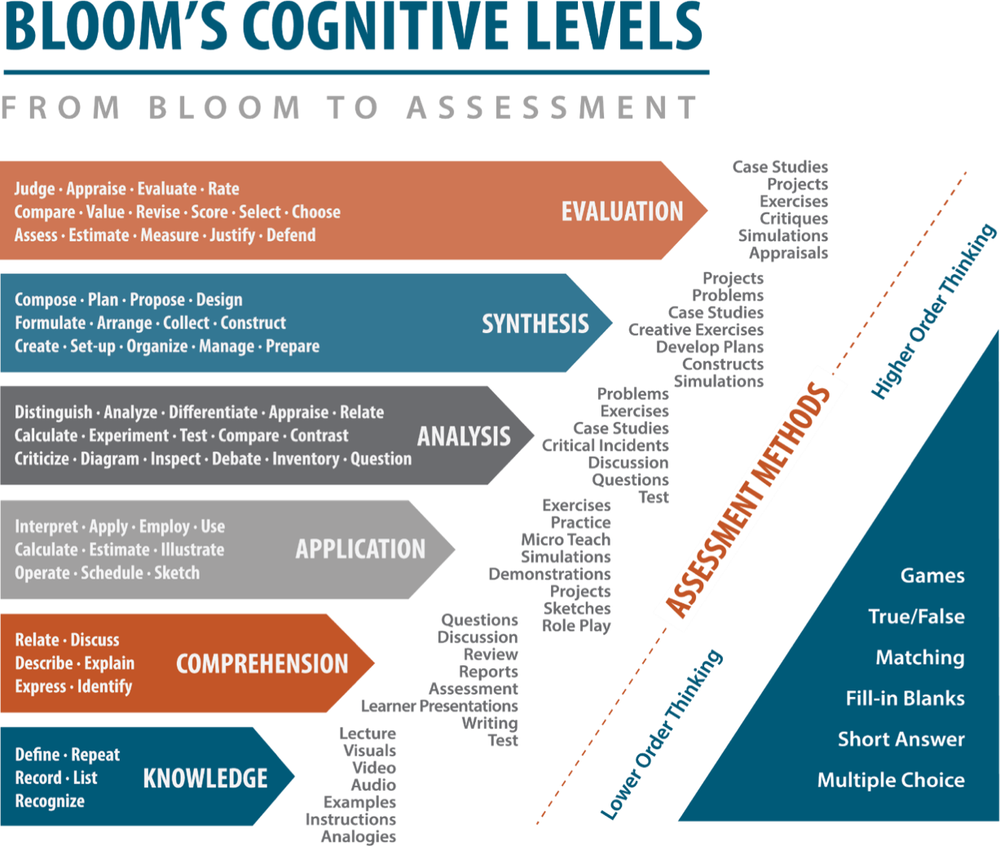

Bloom’s Tie To Learning Outcomes and Assessment

