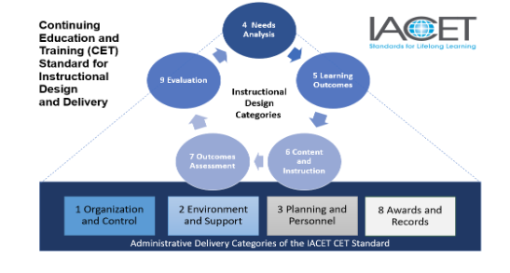
IACET Application Documentation & Communicaton Planning

Worksheet

Part One: My Plan for Documenting Policies and Processes

Actions | Who Can Help | When Can I Start?

Part Two: My Plan for Collecting Evidence

Actions | Who Can Help | When Can I Start?

Part Three: My Plan for Communicating (Changes and IACET Accreditation Project)

Actions | Who Can Help | When Can I Start?

